Name:
Food Web
Who Eats Whom
- Color code the organisms (name only) on the left side of the chart:
PRIMARY CONSUMERS=GREEN
SECONDARY CONSUMERS=ORANGE
TERTIARY CONSUMERS=RED
DECOMPOSERS=BLUE
- On the back, create a food web by connecting each organism to every organism that it eats. Connect the organisms b using arrows that are the same color as the organism’s highlight color (grasshopper is a primary consumer so it should be connected to the organisms it consumes with green arrows). Be sure to create the connection so the arrows are pointing to the thing doing the eating or gaining the energy.
Owl | eats | Field mouse, Vole Bird, Shrew, Mole, Lizard, Grasshopper, Moth, Beetle
Bird | eats | Seeds, Grasshopper, Moth, Beetle
Fieldmouse | eats | Grass, Seeds, Grasshopper, Moth, Beetle
Vole | eats | Plant Roots, Grass, Seeds, Grasshopper, Moth, Beetle
Shrew | eats | Grasshopper, Moth, Beetle
Mole | eats | Grasshopper, Moth, Beetle
Lizard | eats | Seeds, Flowers, Grasshopper, Moth, Beetle
Grasshopper | eats | Plants, Seeds
Beetle | eats | Plants, Flowers, Seeds
Butterfly | eats | Flowers
Mushroom | eats | Organic Materials, Dead Bodies
Soil Bacteria | eats | Organic Materials, Dead Bodies
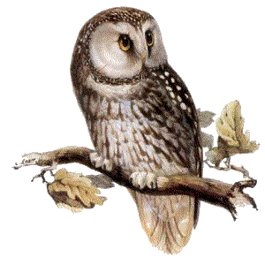

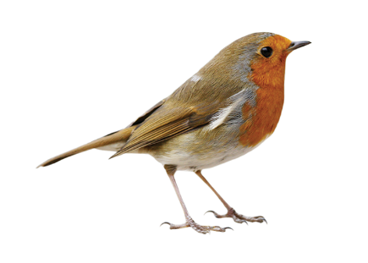
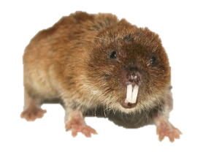
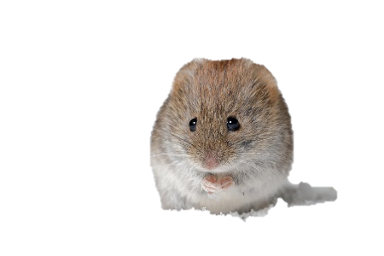
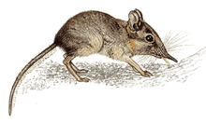
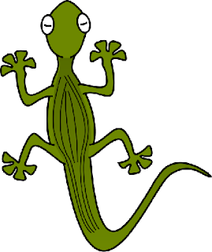
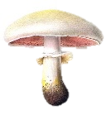
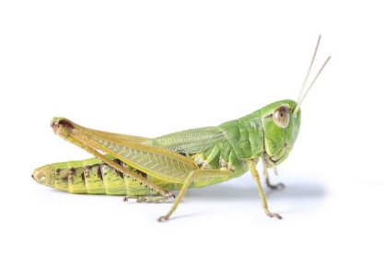
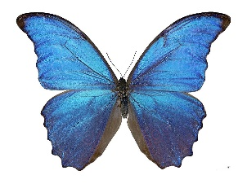
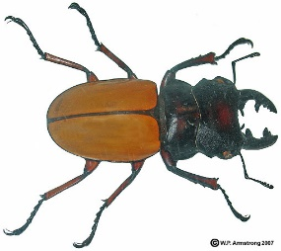
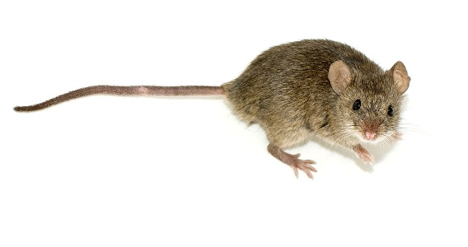
Bird
Mole
Grasshopper
Seed
Vole
Flower
Plant
Mushroom
Beetle
Butterfly
Shrew
Lizard
Owl
Field Mouse
Bacteria

